AD LIFECYCLE ARTIFACT | Internal Design Document – V4.3  Detail Component Design
Application: OMS | Project Name: Order Management System
Module/Component/Executable:  Quality Control Framework | Project Initiation Code: OMS
Author: IRI GOC | Project Code: OMS
Language: Java | Time Tracking Code:
The Internal Design describes the new module or modifications to an existing module to meet the desired functional changes as specified in the External Design. The document should reference all aspects of the module being modified including detailed references to inputs and outputs. The document should also include test-planning guidelines to support Unit Testing.
1 VERSION HISTORY 2
2 OVERVIEW 2
2.1 Summary 2
2.2 Out of Scope 2
2.3 Architecture Overview 3
2.4 Detailed View 4
3 REQUIREMENTS TRACEABILITY MATRIX 5
4 FUNCTIONAL & LOGICAL SPECIFICATIONS 6
I.01 QC Channel 6
I.02 Exception Handler 9
I.03 Event Logger 11
I.04 Deployment and Packages: 22
I.05 Usage of QC Framework 23
5 DESIGN ASSUMPTIONS. 28
6 DESIGN RISKS. 28
7 ARCHITECTURE IMPLICATIONS 28
8 DATABASE MODEL 29
9 QUALITY CONTROL 30
10 INTERNAL DESIGN SIGNOFF (AD Only) 30
11 APPENDIXES 30
User message key definition guideline: 30
User messages used in OMS application: 30

VERSION HISTORY

Version | Description of Changes | Date | Author
1.0 | Initial release | 9/6/05 | Vinod / Bala
1.1 | Updated according to Mike’s feedback:  Added channel instantiation information  Added code example  Added Appendix | 9/19/05 | Vinod

OVERVIEW

Summary
This document covers the detailed design of Quality Control Framework. The document discusses the implementing classes and the different sequence diagrams depicting the flows in QC Framework.
The QC Framework will be used by the OMS application for exception handling and event logging (To JETS).

Out of Scope

NA

Architecture Overview

The QC Framework can be divided into following different components:

- QC Channel
- Exception Handler
- Event Logging

- QC Channel:
In QC Framework Exception Handling and Event logging is done using the Concurrent Channels. Concurrent channels acts as a stack, where all the objects (Error object and event log object) will be stacked and the channel picks up each object and runs the execute method of that object.
Whenever the OMS application wants to handle an exception or log an event, it will create an Error object or Event object respectively and place it on the channel. The channel picks up the objects one-by-one and executes the execute method of the object.
- Exception Handler:
All the exceptions in OMS application is implemented using nested exception handling strategy. This strategy will allow the application to capture all the error details in each layer, which will help in logging a detailed exception stack trace.
- Event Logging:
All the process steps in OMS application is logged to JETS as events. OMS application uses the web service exposed by JETS system to log the events. But the communication between OMS and JETS are made asynchronous by bringing in JMS messaging between the two systems.
OMS application will send the event messages to the JMS queue. The queue listener will pickup the event messages from the queue and will send a synchronous event message to the JETS system using the web service exposed by JETS.

Logical architecture of the QC Framework is as given in the below given diagram:

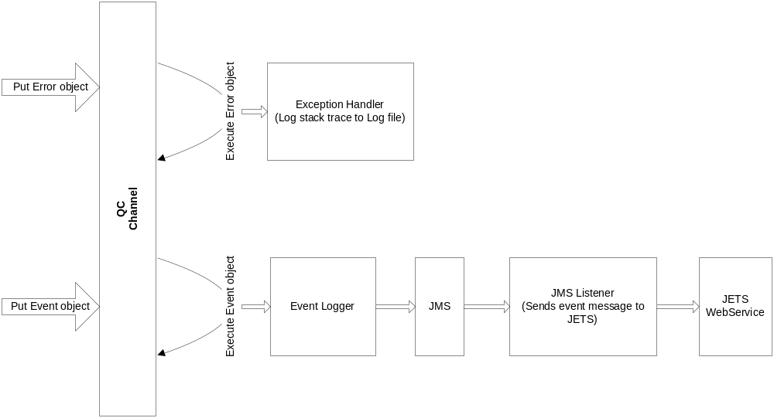

Detailed View
Provided in functional and logical specifications

REQUIREMENTS TRACEABILITY MATRIX

E.D. # | External Design Functional Change | I.D. # | Internal Design Functional Change
 |  | I.01 | QC Channel:  This section explains the QC Channel implementation and different process flows inside the channel.
 |  | I.02 | Exception Handler:  This section explains the exception handling strategy for the OMS application
 |  | I.03 | Event Logger:  This section explains the Event Logging (JETS logging) implementation for OMS application
 |  | I.04 | Deployment and Packages:  This section explains the package structure used by the QC Framework classes. And also explains the deployment descriptors used to deploy the QC Framework components.
 |  | I.05 | Usage of QC Framework:  This section explains how to use the QC Framework.

FUNCTIONAL & LOGICAL SPECIFICATIONS

I.01 QC Channel
QC Framework channel is the entry point for the Quality Control processes. This entry point is implemented using Active Objects pattern, where the execution is decoupled from the invocation. To accomplish this there are a few key structures: Channels, and Events. Each process is wrapped as an event and put onto a channel. A separate thread then takes this event and executes the process.

There will be two synchronized channel objects (one for Error events and another for Log events) created on the application start up and these channels will be ready to receive the event objects (Error event or Log Event). The QC consumer will create the respective events (Error event or Log Event) and will place the event object on the respective channels. The listener thread will pick up the event object and will execute the “execute” method of the Error/Log event objects.

The below given diagram explains the flows in the QC Channel:
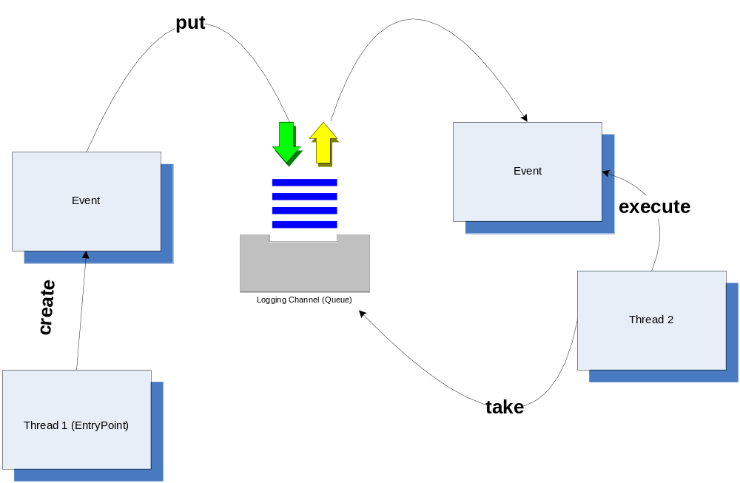

This design will address the need of a-synchronous processing of exception handling and logging, however callback methods on the event objects can be established to achieve the synchronous behavior.

QC Channel will be instantiated on the first call to the QC Framework, and this instantiated channel will be used for further logging and exception handling.

Class Diagrams: Following are the various classes used in QC Channel implementation

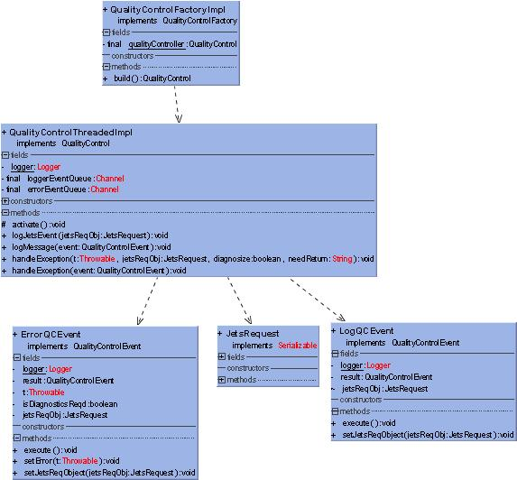

Sequence Diagrams:

Sequence diagram which explains the processing of error object in the QC Channel:

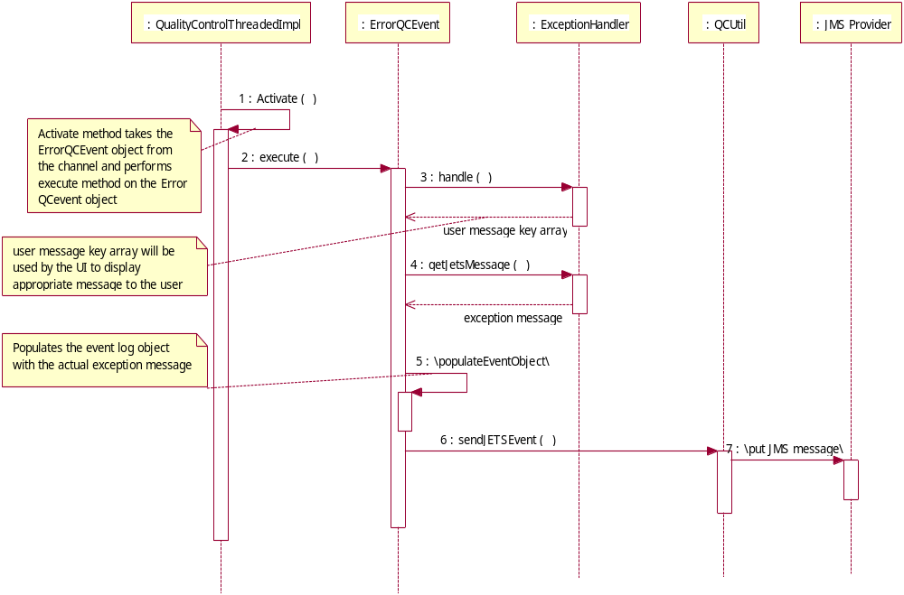

Sequence diagram which explains the processing of event log object:

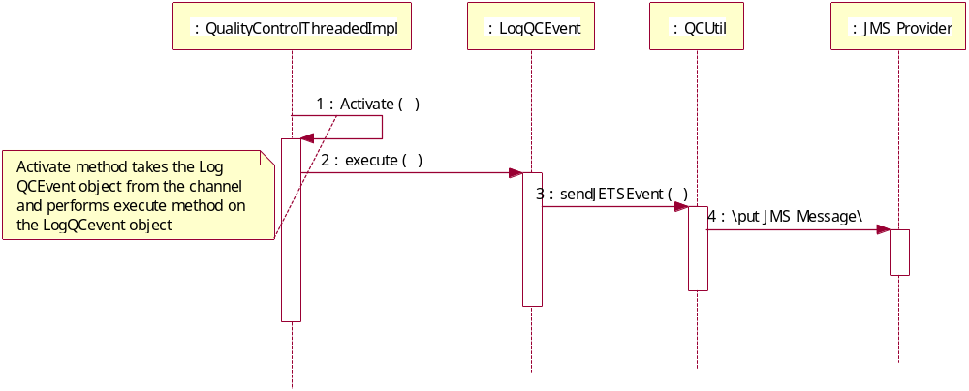

I.02 Exception Handler

The purpose of exception definitions and handling is to capture any failures in the application and propagate appropriate messages to the application user and log a detailed stack trace for debugging purpose.

In order to achieve above stated functionality, the developer shall be allowed to add useful messages to the exception object as and when required in different layers (Data access layer, EJB layer, Business Delegate layer). This is facilitated by the design as explained below:

The exceptions are divided into two categories:
- InforesCheckedException
This exception is used as a parent exception for all the Application Exceptions and the System Exceptions.
Application (Business) exceptions shall be created as and when required and shall be propagated to the caller.
System Exceptions can be can be created in each layer and shall be propagated to the caller, during the course of propagation System Exception shall be converted to the layer specific exception (Please refer the example given below in the Usage section). This approach offers following advantages as compared to the approach of creating a runtime exception for all the system exceptions.
  - Developer will be able add required information in each layer, which will help in debugging the application and logging a detailed message in the JETS system.
  - Each layer will handle only one type of system exception. For example; EJB layer will always catch DAOSystemException from the DAO layer.
  - This approach gives the flexibility of performing any special activity for a particular type of exception. For example; if developer catches a ServiceLocatorException, he can try to ping another JNDI registry.
  - Developer will have the flexibility of changing the user messages at each layer.
- InforesUncheckedException
This exception is used as a parent exception for all the Runtime exceptions.

Exception handling:
Exceptions shall be handled at the View layer (Action class) or the service end point.

- Exception handling at the View layer (Action class and JSP):
BusDelSystemException and Application exception shall be caught in the action class and shall be handled accordingly.

In case of SystemException, complete stack trace gets logged to a log file and this method returns a String array. The String array contains user message id as first element and parameters as the next elements. User message id and parameters is used to display the proper message to the user.

In case of Application Exception, user message array is retrieved from the exception object. This array contains user message id as first element and parameters as the next elements. User message id and parameters is used to display the proper message to the user.

In both the exception scenarios, JETS event message gets logged with appropriate error messages.

- Exception handling at the service end point (Webservice):
Business Delegate System exception and application exception shall be caught in the service end point and shall be propagated to the caller as appropriate fault messages.

Class Diagrams: Following are the basic classes used in Exception Handling

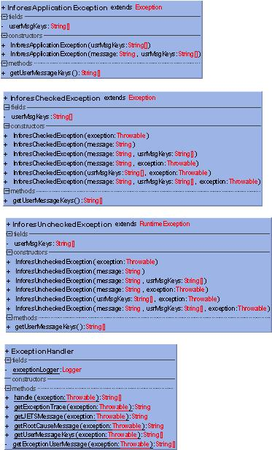

I.03 Event Logger

The purpose of JETS logging is to facilitate the logging of important process and process steps into a system (JETS) from where the tracking can be done. In order to achieve this functionality JETS has exposed a web service which can be used to log the events, this web service accepts an xml document as input and returns back an xml document containing the result. The result contains a string representing values as confirmed or failed.

Please refer the wsdl format published by JETS (draft version) below:
<?xml version="1.0" encoding="UTF-8"?>
<wsdl:definitions xmlns:soap="http://schemas.xmlsoap.org/wsdl/soap/" xmlns:tns="http://infores.com/JetsMessage/" xmlns:wsdl="http://schemas.xmlsoap.org/wsdl/" xmlns:xsd="http://www.w3.org/2001/XMLSchema" name="JetsMessage" targetNamespace="http://infores.com/JetsMessage/">
<wsdl:types>
<xsd:schema targetNamespace="http://infores.com/JetsMessage/" xmlns:xsd="http://www.w3.org/2001/XMLSchema">
<xsd:element name="JETSResponse">
<xsd:annotation>
<xsd:documentation>The response will have a status value of confirmed/failed. If the value is confirmed the message is accepted. If the value is failed, there is a problem with data-elements or syntax of the message</xsd:documentation>
</xsd:annotation>
<xsd:complexType>
<xsd:attribute name="Status" type="xsd:string" use="required"></xsd:attribute>
</xsd:complexType>
</xsd:element>
<xsd:element name="JETSRequest">
<xsd:annotation>
<xsd:documentation>These are the mandatory input fields for the JETSMessage. If the datafield is empty, please provide an empty string</xsd:documentation>
</xsd:annotation>
<xsd:complexType>
<xsd:attribute name="ReportingComponent" type="xsd:string" use="required"></xsd:attribute>
<xsd:attribute name="Status" type="xsd:string"></xsd:attribute>
<xsd:attribute name="JobId" type="xsd:string" use="required"></xsd:attribute>
<xsd:attribute name="EventDate" type="xsd:time" use="required"></xsd:attribute>
<xsd:attribute name="EventType" type="xsd:string" use="required"></xsd:attribute>
<xsd:attribute name="Category" type="xsd:string" use="required"></xsd:attribute>
<xsd:attribute name="Application" type="xsd:string" use="required"></xsd:attribute>
<xsd:attribute name="Mode" type="xsd:string"></xsd:attribute>
<xsd:attribute name="Program" type="xsd:string"></xsd:attribute>
<xsd:attribute name="ErrorId" type="xsd:positiveInteger" use="required"></xsd:attribute>
<xsd:attribute name="ErrorMessage" type="xsd:string"></xsd:attribute>
<xsd:attribute name="MessageDetails" type="xsd:string" use="optional"></xsd:attribute>
<xsd:attribute name="Target" type="xsd:string" use="optional"></xsd:attribute>
<xsd:attribute name="Attachment" type="xsd:string"></xsd:attribute>
</xsd:complexType>
</xsd:element>
</xsd:schema>
</wsdl:types>
<wsdl:message name="JETSResponse">
<wsdl:part element="tns:JETSResponse" name="JETSResponse"/>
</wsdl:message>
<wsdl:message name="JETSRequest">
<wsdl:part element="tns:JETSRequest" name="JETSRequest"/>
</wsdl:message>
<wsdl:portType name="JetsMessage">
<wsdl:operation name="NewOperation">
<wsdl:input message="tns:JETSRequest"/>
<wsdl:output message="tns:JETSResponse"/>
</wsdl:operation>
</wsdl:portType>
<wsdl:binding name="JetsMessageSOAP" type="tns:JetsMessage">
<soap:binding style="document" transport="http://schemas.xmlsoap.org/soap/http"/>
<wsdl:operation name="NewOperation">
<soap:operation soapAction="http://infores.com/JetsMessage/NewOperation"/>
<wsdl:input>
<soap:body use="literal"/>
</wsdl:input>
<wsdl:output>
<soap:body use="literal"/>
</wsdl:output>
</wsdl:operation>
</wsdl:binding>
<wsdl:service name="JetsMessage">
<wsdl:port binding="tns:JetsMessageSOAP" name="JetsMessageSOAP">
<soap:address location="http://tempuri.org"/>
</wsdl:port>
</wsdl:service>
</wsdl:definitions>

Class Diagrams: Following class diagram lists all the classes used in Event Logging

JETS Message listener classes:

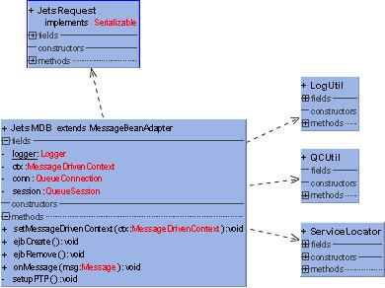
Timer Service classes:

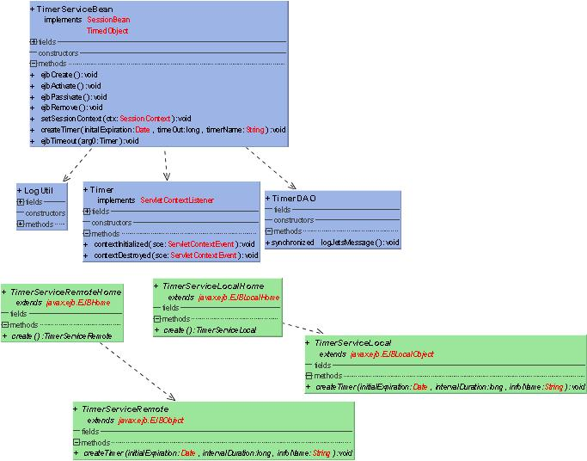
Classes used for writing and reading event message xml documents:

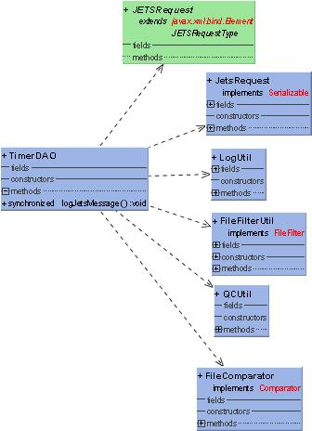

Utility and value object classes used by Event Logging:

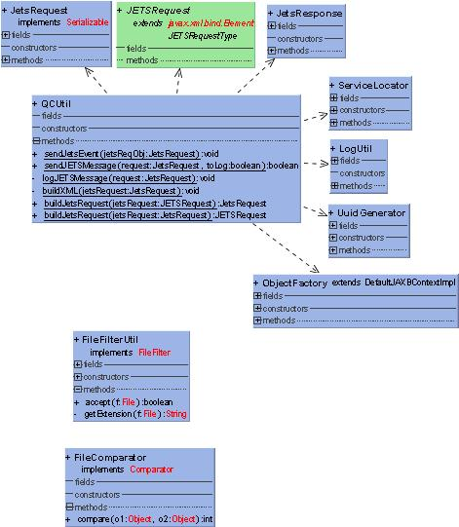

Logging event message:
The process of event logging can be explained with the following steps:

Step1: Create JETS message (In Action class or Service End point)
Step 2: Send an a-synchronous message to the JMS provider.
Step 3: Message listener reads the message from the message queue and generates the event message xml document.
Step 4: Consume web service exposed by JETS and send xml document to it through web service.

Following sequence diagram depicts the sequence of above said steps:
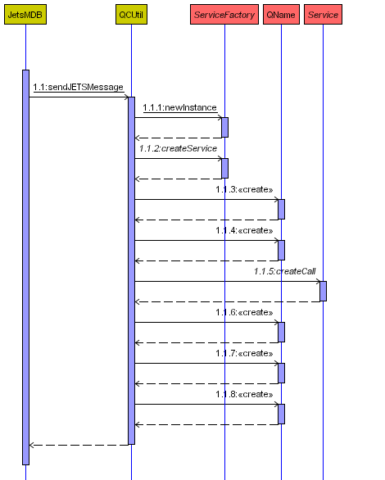

Event message persistence and recovery:
In case of any failures in between the “process of generation of event message” and “sending of event message to JETS”, the event message needs to be persisted and recovered. The service which recovers the event message will try to send the message to JETS again, and this attempt will be made at regular interval of time till the service successfully sends event message to JETS.

Event messages are persisted in the form of XML documents and JAXB is used to write and read the XML files. Timer Service provided by EJB Container is used to achieve the scheduled recovery process.
The process of message persistence and recovery is depicted in the following diagram:
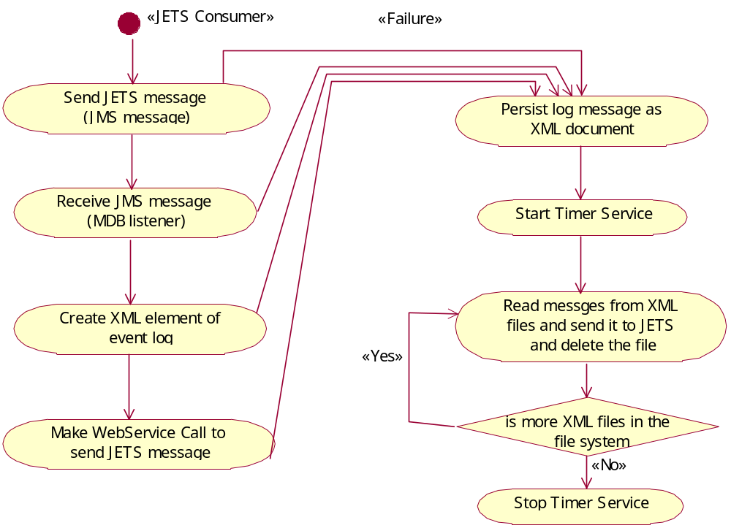

Following sequence diagrams explains all the flows involved in persistence and recovery process:

Sequence diagram for Message persistence:

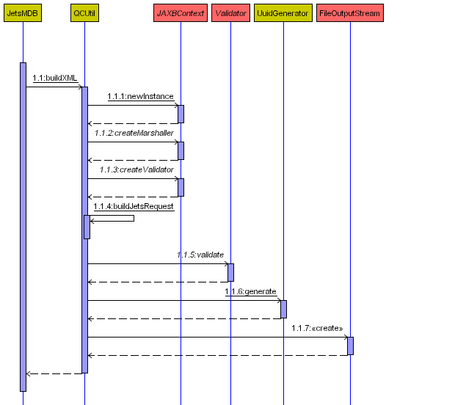

Sequence diagram for Message recovery:

Sequence diagram for Creation of Timer Service:
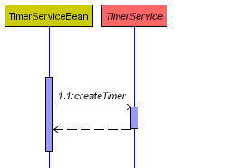
Sequence diagram for message recovery:
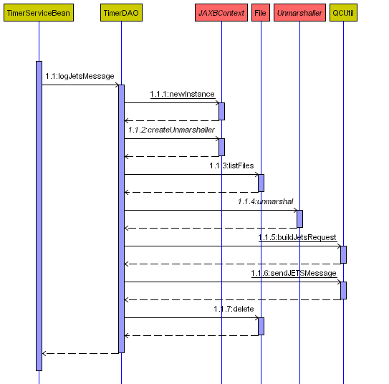

I.04 Deployment and Packages:

Packages:

The packages used QC Framework are listed below:

QC Channel implementation: com.infores.oms.services.qc
Event Message listener implementation: com.infores.oms.services.ejb.jets
Event message timer service implementation: com.infores.oms.services.ejb.timer
JAXB implementation for reading and writing XML documents: com.infores.oms.services.qc.jets

Deployment descriptors:

jboss.xml:
<message-driven>
<ejb-name>JetsMDB</ejb-name>
<destination-jndi-name>queue/B</destination-jndi-name>
<configuration-name>
Standard Message Driven Bean
</configuration-name>
</message-driven>

ejb-jar.xml:
<message-driven>
<ejb-name>JetsMDB</ejb-name>
<ejb-class>com.infores.oms.services.ejb.jets.JetsMDB</ejb-class>
<transaction-type>Container</transaction-type>
<acknowledge-mode>Auto-acknowledge</acknowledge-mode>
<message-driven-destination>
<destination-type>javax.jms.Queue</destination-type>
</message-driven-destination>
<resource-ref>
<res-ref-name>jms/QCF</res-ref-name>
<res-type>javax.jms.QueueConnectionFactory</res-type>
<res-auth>Container</res-auth>
</resource-ref>
</message-driven>

web.xml: (Configuration required to start the Timer service on Application server start-up)
<listener>
<listener-class>
com.infores.oms.services.ejb.timer.Timer
</listener-class>
</listener>

I.05 Usage of QC Framework

Typical usage of QC Framework is explained using an exception condition occurring at the DAO layer and how it is propagated to the UI layer:

Step 1: Create order request comes from the UI (JSP)
Step 2: Action class creates an event log for create order process; propagates the create order call to the Business delegate layer
Step 3: Business delegate layer propagates the call to the EJB
Step 4: EJB propagates the call to the DAO layer.
Scenario 1: SQL exception occurs at the DAO layer
Step 5: DAO layer creates a DAO Exception and propagates back to the EJB layer
Step 6: EJB Layer converts the DAO Exception to EJB Exception and propagates back to Business Delegate layer
Step 7: Business Delegate layer converts the EJB Exception to Business Delegate exception and propagates back to Action class.
Step 8: Action class catches the Business Delegate exception; creates an event log for create order process failure and handles the exception using QC Framework.
Scenario 2: DAO layer fulfills the call without any exception
Step 5: Action class creates and event log for create order process completion and logs the event using QC Framework.
Scenario 3: Generation and propagation of Business (Application) Exception.
Step 4: EJB Layer creates a Business (Application) Exception and throws it back to the Business Delegate layer.
Step 5: Business Delegate layer throws up the Business (Application) Exception to the Action class
Step 6: Action class catches the Business (Application) Exception and forwards the control to error.jsp or input jsp page.

Below given are the pseudo code examples for QC Framework implementation:

JSP or Service End point:

In JSP (error.jsp / input page):

Get the user message keys from the action errors, translate the keys and display it to the user.

In Service End points (Web Service):

Try {

} catch (EJBSeystemException ejbExc) {
//get the exception messages and convert to a proper Service Exception and throw the exception
} catch (ApplicationException appExc) {
//get the user message keys
//translate the keys to proper messages
// throw service specific application exception
}

Action class:
OrderActionClass {
Execute () {
Try {

//Create order process
/*Send a message to JETS indicating Order Creation process has started */
//Build jets request object (com.infores.oms.data.dataobjects.JetsRequest) and send the object to QC Framework. //

QualityControl.factory.build().logJetsEvent(jetsReqObj)

//Create order
OrderBean.createOrder();

/*Send a message to JETS indicating Order creation process is successful */
//Build jets request object (com.infores.oms.data.dataobjects.JetsRequest) and send the object to QC Framework. //

QualityControl.factory.build().logJetsEvent(jetsReqObj)

} catch (ApplicationException appExc) {

//Create order process has failed
/*Send a message to JETS indicating Order Creation process has failed */
//Build jets request object (com.infores.oms.data.dataobjects.JetsRequest) and send the object to QC Framework. //

QualityControl.factory.build().logJetsEvent(jetsReqObj)

//Forward the request to error.jsp or input page

} catch (SystemException sysExc) {

//Create order process has failed
/*Send a message to JETS indicating Order Creation process has failed */
//Build jets request object (com.infores.oms.data.dataobjects.JetsRequest) and send the object to QC Framework. //

String[] userMsgKeys = QualityControl.factory.build().handleException(sysExc, jetsReqObj, false, YES");

//Add the user message keys to Action Error object

ActionErro!.add ( userMsgKey )

//Forward the request to error.jsp

}
}
}

Business Delegate:

OrderBusinessDelegate throws ApplicationException, BusDelSystemException {
Try {
OrderBean.createOrder ()
} catch (EJBSystemException ejbExc) {
String[] param = {oms.delegate.createorderexc}
thow new BusDelSystemException(“Exception in business delegate layer ”, param, ejbExc)
} catch (Exception exc) {
String[] param = {oms.delegate.exckey}
throw new BusDelSystemException(“Some Exception in business delegate layer ”, param, exc)
}

}

EJB / Transaction layer:

OrderBean throws ApplicationException, EJBSystemException {
Try {
OrderBean.createOrder ()
} catch (DAOSystemException daoExc) {
String[] param = {oms.ejb.createorderexc}
throw new EJBSystemException(“Exception in EJB layer ”, param, daoExc)

} catch (Exception exc) {
String[] param = {oms.ejb.exckey}
throw new EJBSystemException(“Some Exception in ejb layer ”, param, exc)
}

}

Hibernate (DAO) layer / CRUD Service:

OrderDAO throws DAOSystemException {
Try {
HibernateSession.save ()

} catch (HibernateException hibExc) {
String[] param = {oms.hibernate.key}
throw new DAOSystemException(“Hibernate exception has occured ”, param, hibExc)

}

}

Note: While defining the user message key array, first array element should be the key and the parameters can be added as the subsequent array elements.

For example:
If the resource bundle entry is like
oms.delegate.createexc=EJB create exception occurred while instantiating the bean {0}

then the user message key definition should be
String[] key = { “oms.delegate.createexc “, “Order Bean”}

DESIGN ASSUMPTIONS.

- Enterprise Service Bus will be used for the service call between two systems within the MK Factory and this design is done adhering to this standard.
- Any changes in the JETS schema will be communicated to the OMS team.
- Event message persistence is done in the form of XML document. This will be re-engineered after the migration to DB2 database.

DESIGN RISKS.

- The design of QC Framework is done using the latest J2EE version (1.4) and any change in this version (<1.4) will result in redesigning the message recovery mechanism.

ARCHITECTURE IMPLICATIONS

NA

DATABASE MODEL

NA

QUALITY CONTROL

JUnit test cases are written for the following methods:

LogJetsEvent
HandleException

INTERNAL DESIGN SIGNOFF (AD Only)

Signoff - Name | Functional Area | Signoff Date

APPENDIXES

User message key definition guideline:

User message keys for Application exceptions:

<project>.<module>.key example: oms.security.invalidcredentials
<project>.common.key example: oms.common.invalidparameter

User message keys for System Exceptions:

<project>.<layer>.key example: oms.ejb.bomcreateexc
<project>.<category>.key example: oms.cat_file.filenotfoundexc

User messages used in OMS application:

TODO

